Institute of Computer Technology

B. Tech. Computer Science and Engineering

Semester: III

Sub: Object-Oriented Programming

Course Code: 2CSE303

Practical Number:14

Objective: To learn about file handling concepts in Java.

Problem Definition:

**Q.1. What is the concept of file handling in java? Explain with the help of an example.**

**Ans:-** File handling in Java allows performing read, write, and manipulate operations on files. It uses classes from the java.io and java.nio packages.

E.g

import java.io.File;

import java.io.IOException;

public class FileHandlingExample {

public static void main(String[] args) {

try {

File file = new File("example.txt");

if (file.createNewFile()) {

System.out.println("File created: " + file.getName());

} else {

System.out.println("File already exists.");

}

} catch (IOException e) {

System.out.println("An error occurred.");

e.printStackTrace();

}

}

}

**Q.2. Explain the concept of stream class in java java.**

**Ans:-** The Stream class is part of Java's I/O system to handle input and output of data. It represents a flow of data that can be either byte stream or character stream.

Key Classes:

* InputStream/OutputStream: For reading/writing bytes.
* Reader/Writer: For reading/writing characters.

**Q.3. What is the File, FileWriter and FileReader class in Java? Explain with the help of a program example.**

**Ans:-** File Class: Used to create and manage file/directory properties.

FileWriter Class: Used to write data to files.

FileReader Class: Used to read data from files.

E.g

import java.io.FileReader;

import java.io.FileWriter;

import java.io.IOException;

public class FileReaderWriterExample {

public static void main(String[] args) {

try {

FileWriter writer = new FileWriter("example.txt");

writer.write("Hello, this is a FileWriter example.");

writer.close();

FileReader reader = new FileReader("example.txt");

int character;

while ((character = reader.read()) != -1) {

System.out.print((char) character);

}

reader.close();

} catch (IOException e) {

e.printStackTrace();

}

}

}

**Q.4. What is the difference between the BufferedWriter and BufferedReader class in java?**

**Ans:-** 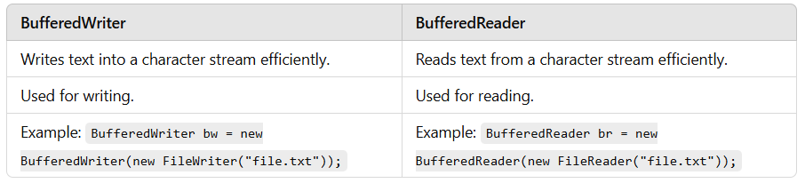

**Q.5. Make an appropriate file handling program in java, where you have to write one paragraphs related to inheritance concept and one paragraph related to Polymorphism concept in text file, and then have to read all the content from text file to**

**terminal/screen.**

**Ans:-** import java.io.*;

public class FileParagraphExample {

public static void main(String[] args) {

try {

BufferedWriter writer = new BufferedWriter(new FileWriter("concepts.txt"));

writer.write("Inheritance is a mechanism in Java where one class acquires the properties of another class.");

writer.newLine();

writer.write("Polymorphism in Java allows a single action to behave differently based on the object.");

writer.close();

BufferedReader reader = new BufferedReader(new FileReader("concepts.txt"));

String line;

while ((line = reader.readLine()) != null) {

System.out.println(line);

}

reader.close();

} catch (IOException e) {

e.printStackTrace();

}

}

}

**Q.6. Make an appropriate file handling program in java, where you have to read minimum 5 employee information like (eid, ename,designation,salary and address) from user, and**

**then have to write all information in a text file, and then have to print all this text file information on terminal/screen.**

**Ans:-** import java.io.*;

import java.util.Scanner;

public class EmployeeInfo {

public static void main(String[] args) {

try {

BufferedWriter writer = new BufferedWriter(new FileWriter("employees.txt"));

Scanner sc = new Scanner(System.in);

for (int i = 0; i < 5; i++) {

System.out.println("Enter Employee ID, Name, Designation, Salary, Address:");

String data = sc.nextLine();

writer.write(data);

writer.newLine();

}

writer.close();

BufferedReader reader = new BufferedReader(new FileReader("employees.txt"));

String line;

while ((line = reader.readLine()) != null) {

System.out.println(line);

}

reader.close();

} catch (IOException e) {

e.printStackTrace();

}

}

}

Output:-

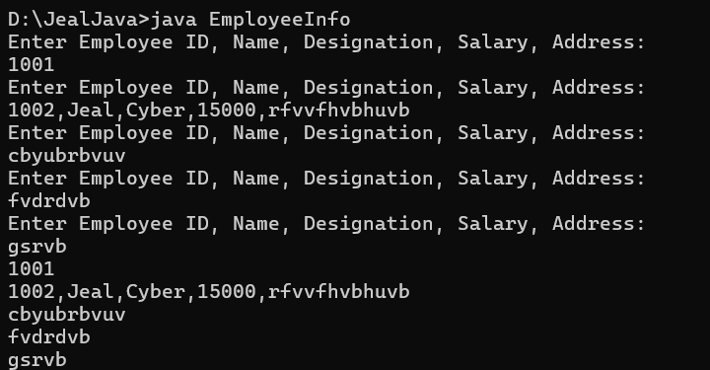

**Q.7. Make an appropriate file handling program in Java, where you have to read minimum 5 product related information like (pid, pname, qty, price) from user and then have to write all this information in a text file, and then have to print all this text file information on terminal / screen the following format like (pid, pname, qty , price , and total price). After printing all this information on screen you have to search individual product information by using pid or pname.**

**Ans:-** import java.io.*;

import java.util.*;

public class ProductInfo {

public static void main(String[] args) {

try {

Scanner sc = new Scanner(System.in);

BufferedWriter writer = new BufferedWriter(new FileWriter("products.txt"));

for (int i = 0; i < 5; i++) {

System.out.println("Enter Product ID, Name, Quantity, Price:");

String data = sc.nextLine();

writer.write(data);

writer.newLine();

}

writer.close();

BufferedReader reader = new BufferedReader(new FileReader("products.txt"));

List<String> products = new ArrayList<>();

String line;

while ((line = reader.readLine()) != null) {

products.add(line);

System.out.println(line);

}

reader.close();

System.out.println("Search by Product ID or Name:");

String search = sc.nextLine();

for (String product : products) {

if (product.contains(search)) {

System.out.println("Found: " + product);

}

}

} catch (IOException e) {

e.printStackTrace();

}

}

}